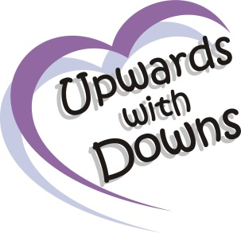
Upwards with Downs
Reg Charity no: 1158649
Membership Form

Name______________________________________________________

Address ___________________________________________________

_______________________________________ Postcode ___________

Home Tel _________________Mobile Phone no: ___________________

Email______________________________________________________

Person with Down Syndromes (Full name & Date of Birth):
Name ________________________________DOB_________________
Siblings Names ______________________________________________

I would like to receive information via; Email Text

Please ensure you read and accept the following statements before signing;
I hereby understand that photographs may be taken at any Upwards with Downs events. I give permission that the photos of all person’s named in this form, can be used on the Upwards with Downs website, Facebook page, Instagram, Twitter and any other Upwards with Downs advertisement. I authorise that if I no longer wish to be a member any existing photos can continue to be used as listed above.
I understand that my child will have to be a member for 6 months before they can participate in the Speech Therapy sessions and 1-1 Swimming Lessons, depending upon waiting list.
I also understand that my data will be kept securely by Upwards with Downs until I cease to be a member of Upwards with Downs at which time my data will removed.
Copy of Data Protection Policy available upon request.

Signed: ____________________________________ Date: _______________

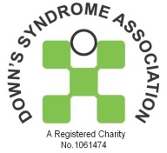
Please return completed form to:
Cristina Griffits
47 Lodge Hall
Harlow
CM18 7SX
Affiliated to the Down’s syndrome association
Or email to: upwardswithdowns@hotmail.com
www.upwardswithdowns.co.uk

